Name: Varsha JJ
Roll No: 48
Batch: B
Date: 25/04/22

NETWORKING & SYSTEM ADMINISTRATION LAB

Experiment No.: 5

Aim
Familiarization of linux command.

Procedure
39. sudo useradd username : To add a new userplus a group and home directory for that user.
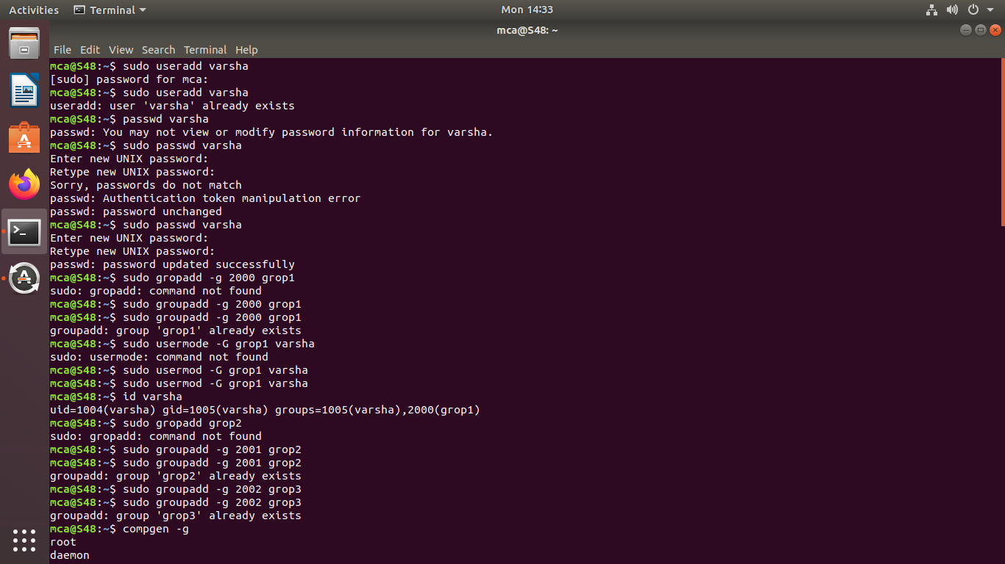
40. sudo passwd username : To give password for the created user.
41. sudo gropadd -g groupid gropname : To add a new grop.
42. sudo usermod -G groupname username : To add new user to grop.

43. id usename: To identify in which grop user exist.

44. compgen -g : To view all the groups.
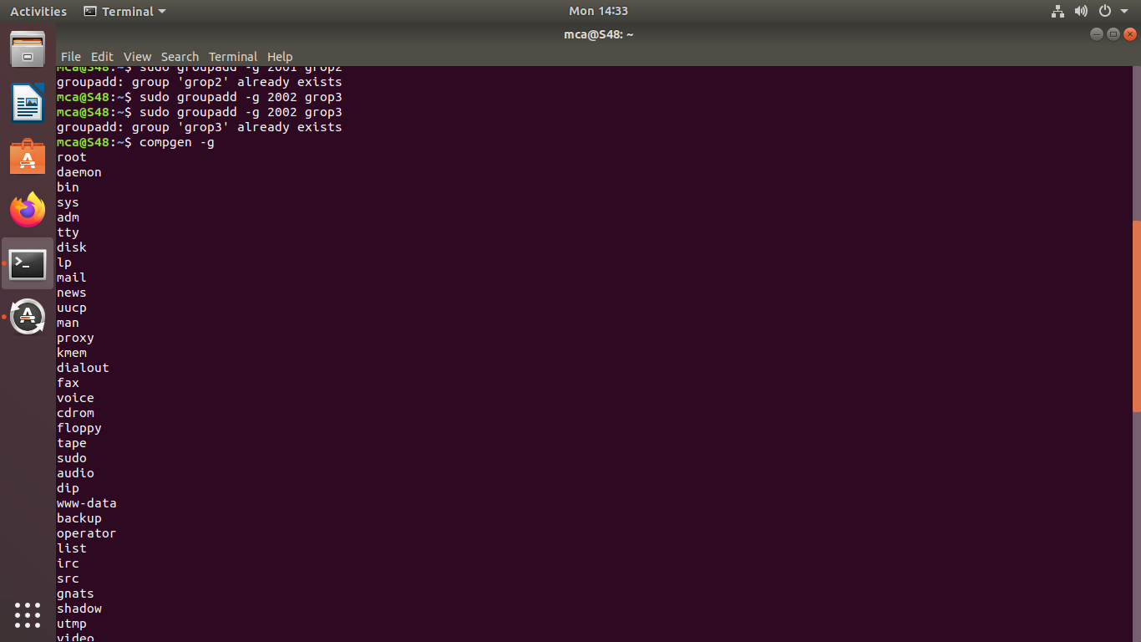

45.sudo userdel username : To delete a particular user.
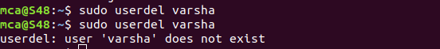

46. sudo gropdel groupname : To delete a particular group.
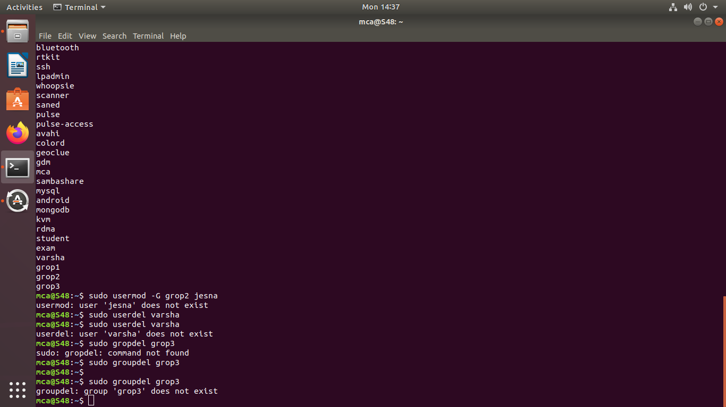

47. compgen -g groupname : To list all grop starting with the given grop name.
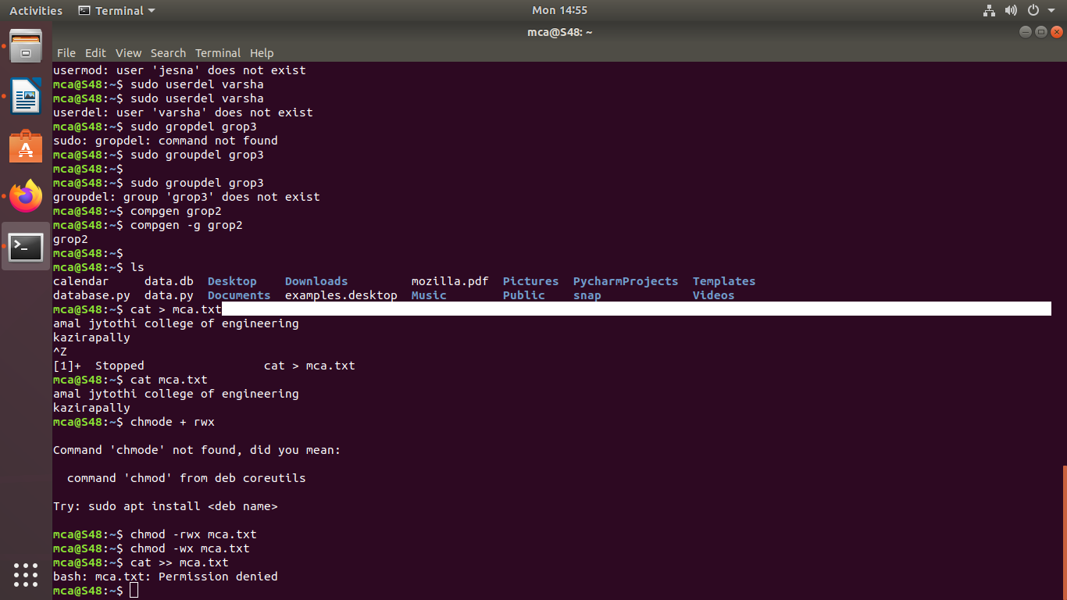

48. chmod -rwx filename :To remove permissions

49. chmod -wx filename : To take out write and executable permissions.

50. chmod +rwx filename : To add permissions.
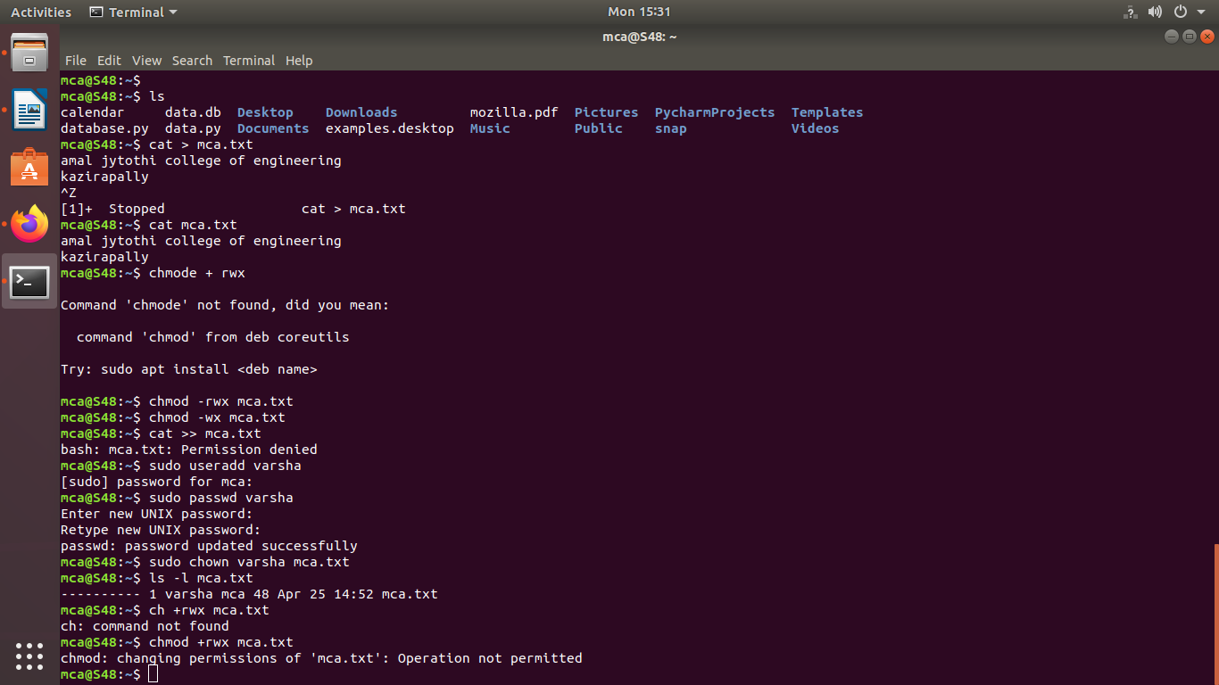
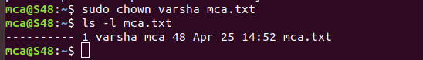
51. sudo chown username filename : To change owner of the file.

